**TITLE OF THE PROJECT**

**Submitted by**

**Name of the Students:** Debasmita Dutta

**Enrolment Number:** 12022002016055

**Section:** D

**Class Roll Number:** 61  
**Stream:** CSE(AIML)

**Subject:** Programming for Problem Solving with Python

**Subject Code:** ESC103(Pr.)

**Department:** Basic Science and Humanities

Under the supervision of

Prof. Dr. Swarnendu Ghosh

**Academic Year: 2022-26**

PROJECT REPORT SUBMITTED IN PARTIAL FULFILLMENT OF THE REQUIREMENTS FOR THE FIRST SEMESTER



**DEPARTMENT OF BASIC SCIENCE AND HUMANITITES**

**INSTITUTE OF ENGINEERING AND MANAGEMENT, KOLKATA**



**CERTIFICATE OF RECOMMENDATION**

We hereby recommend that the project prepared under our supervision by **Debasmita Dutta,** entitled **Bank Management System** be accepted in partial fulfillment of the requirements for the degree of partial fulfillment of the first semester.

_____________________________ ______________________

Head of the Department Project Supervisor

Basic Sciences and Humanities

IEM, Kolkata

# 1. Introduction

If we see at the present scenario we can clearly understand that it is a digital every bank need a system to keep a record of the data of their students and employees respectively. The best way to maintain these records is by creating separate modules and storing the necessary data. In this project we have mainly used the C Programming Language to make a database which can be further used to store necessary data. C is a easy to understandable and user friendly language so anyone can make a program to make such databases according to their needs.

## 1.1Objective

The main objective of this project is to develop a program for creating a bank management system by which we can take data from the user and store it in the desired cells, Because of these project we got to learn "How to create a module", "Relationship between several modules" , and "How to create a modules using C Programming Language"

## 1.2Organization of the Project

This project consists of two sections:

**i) Taking data from the user:** When we run the programme a few terminal prompts instruct us to give the correct input.

**ii)Storing the data into different databases:** After taking the inputs from the user the code analyses data and store it in its respective databases.

# 2. Function Descriptions

There are four databases:

1)create_account: Stores details of a customer

2)deposit: Stores amount to be deposited by the customer

3)withdraw: Stores the amount to be withdrawn

4)check_balance: Checks the current balance of the customer

## 2.1 Functions

* create_account:

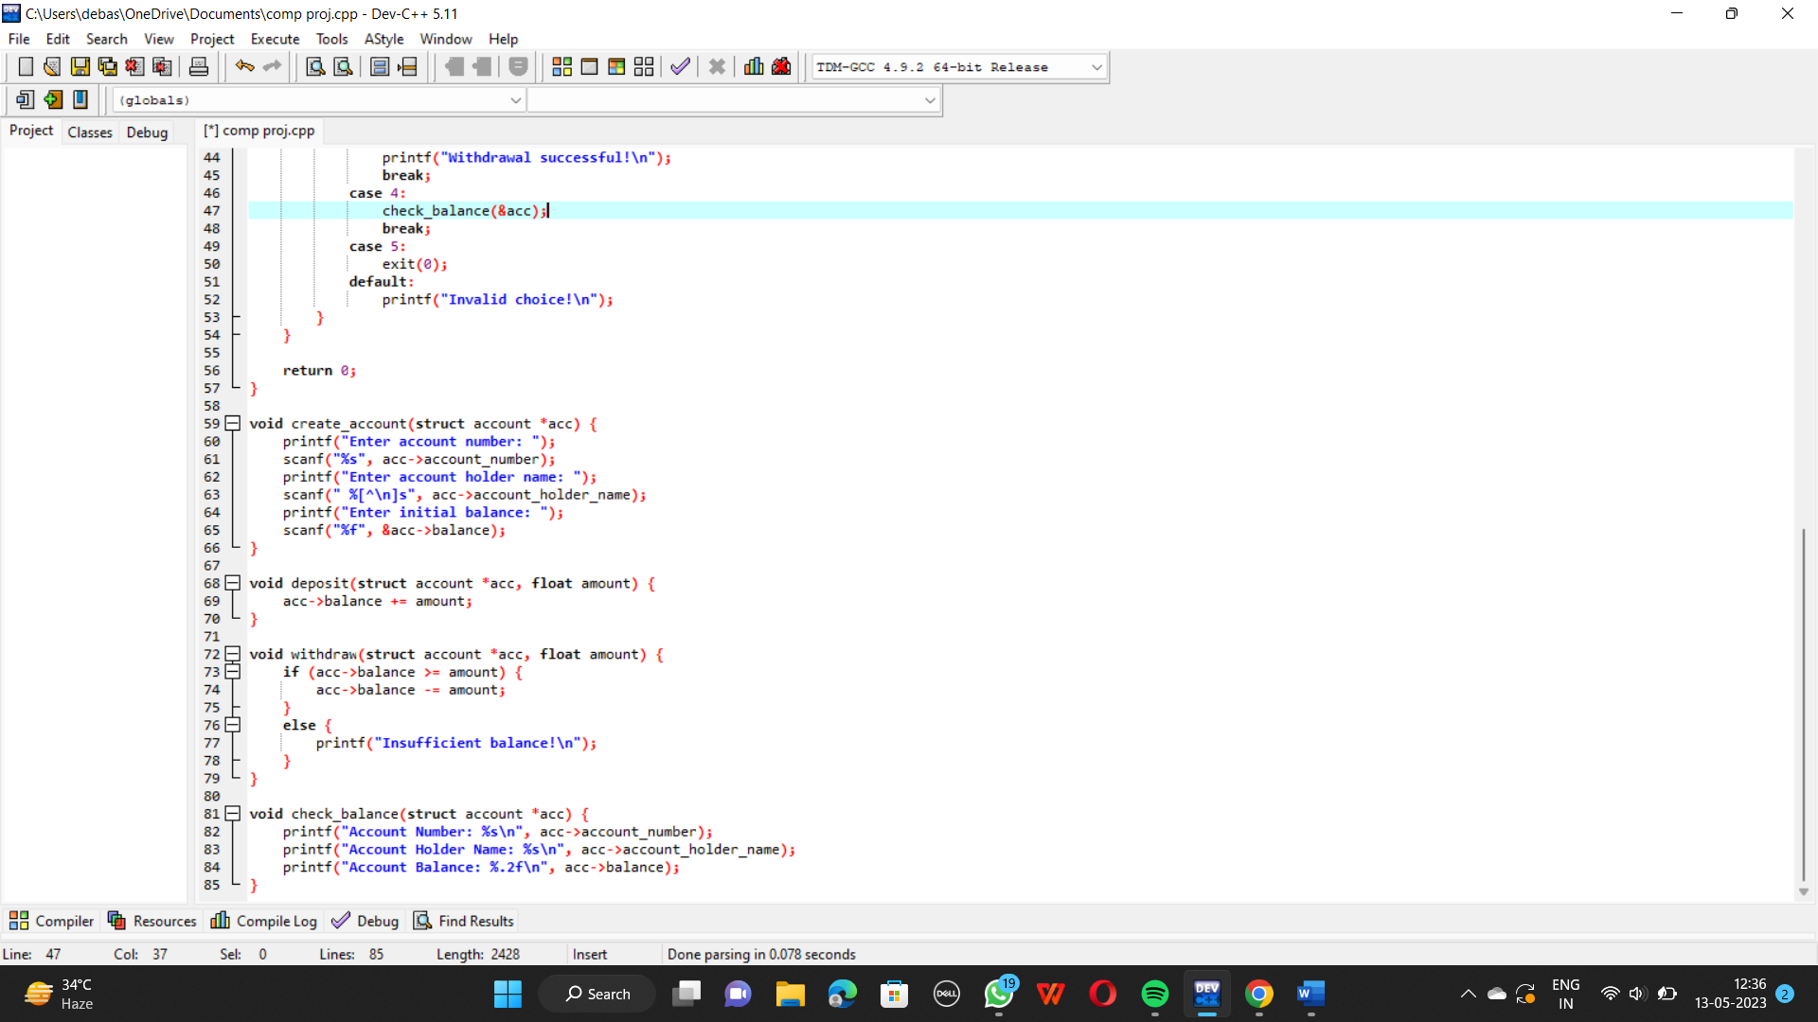

* deposit



* withdraw



* check_balance



**2.2 Variables**

**i)** account_number : To accept and store the account number

**ii)** account_holder_name : To accept and store the account holder name

**iii)** balance : To display the current balance

**iv)** choice : To accept the choice of the user

**v)** amount : To accept the amount to be withdrawn or deposited

# 3. Data Flow and E-R Diagrams

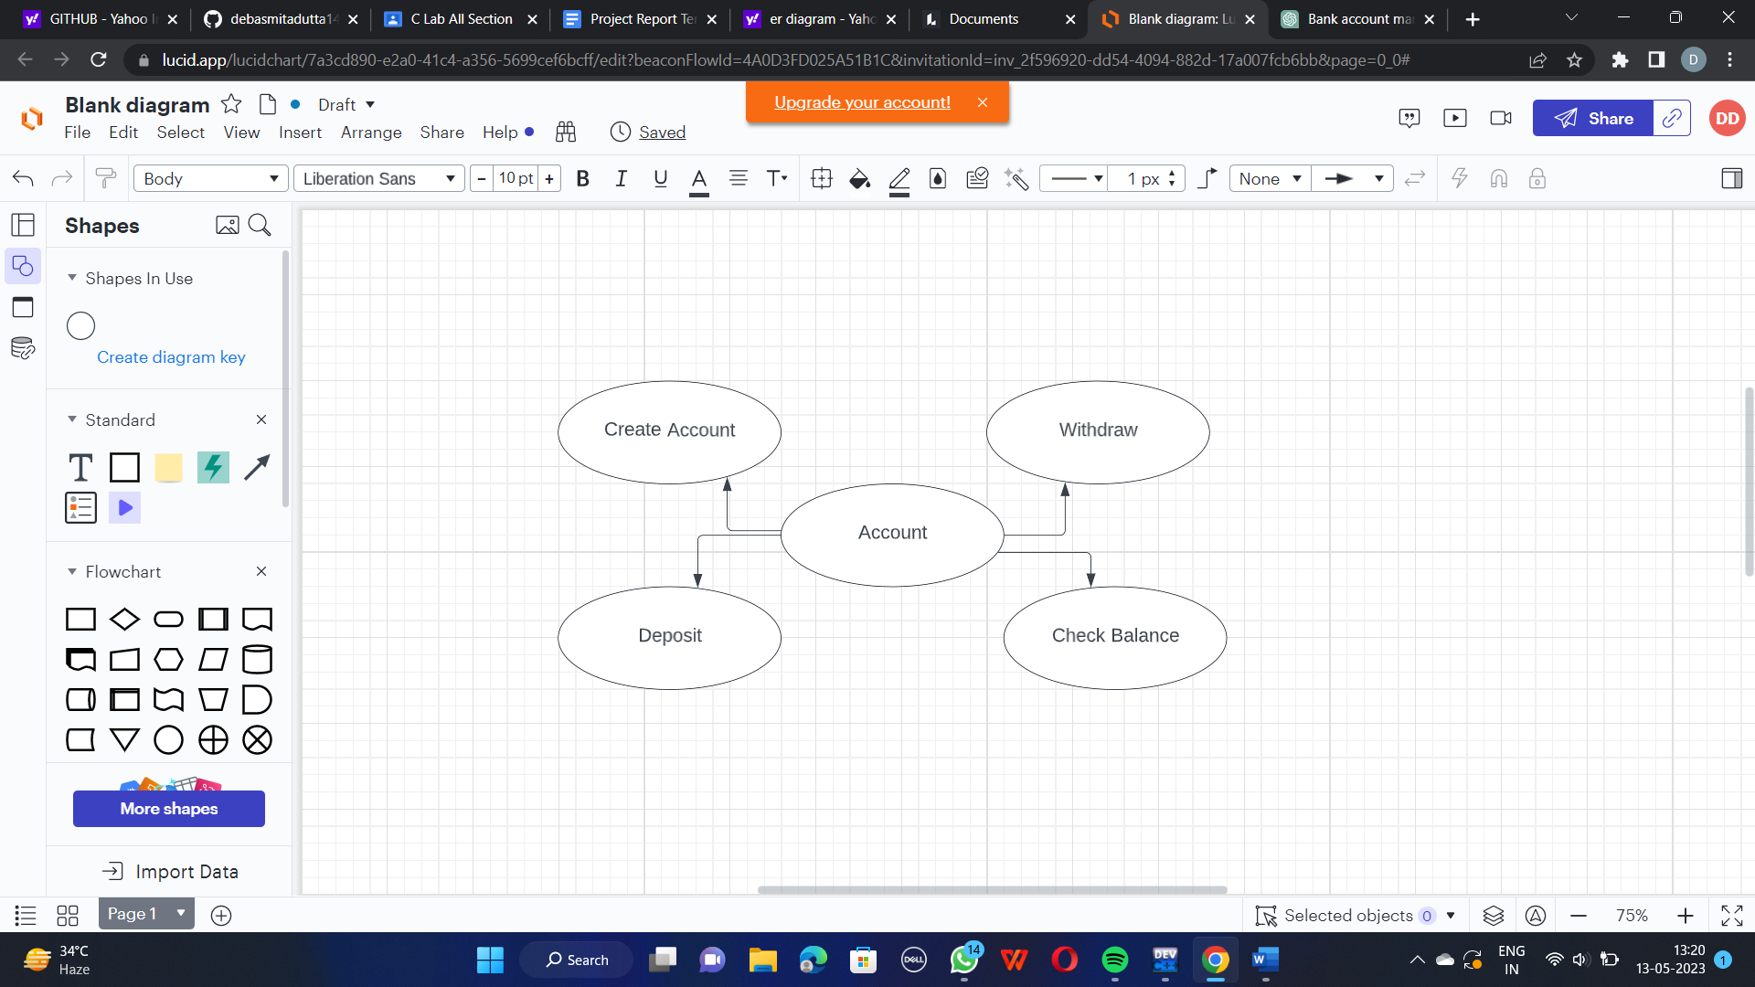

# 4.Programs

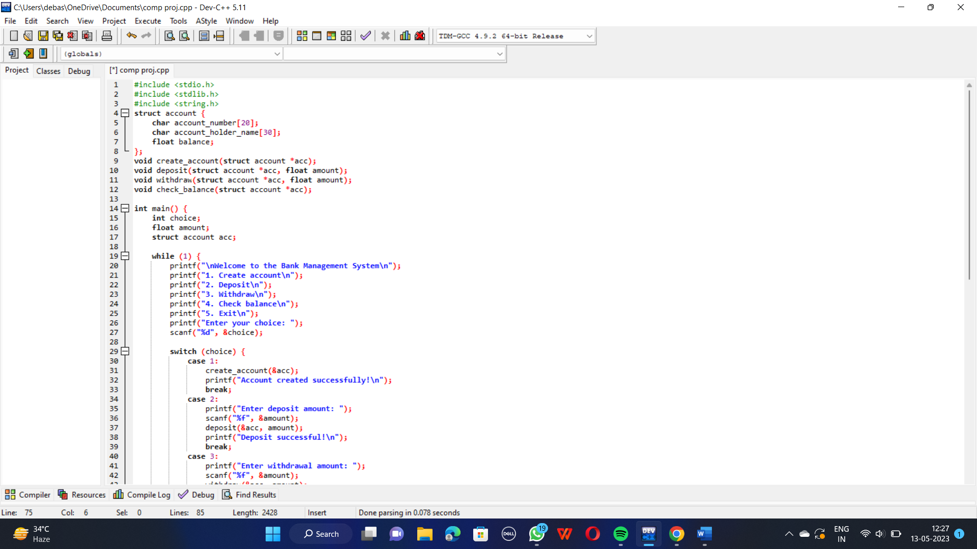 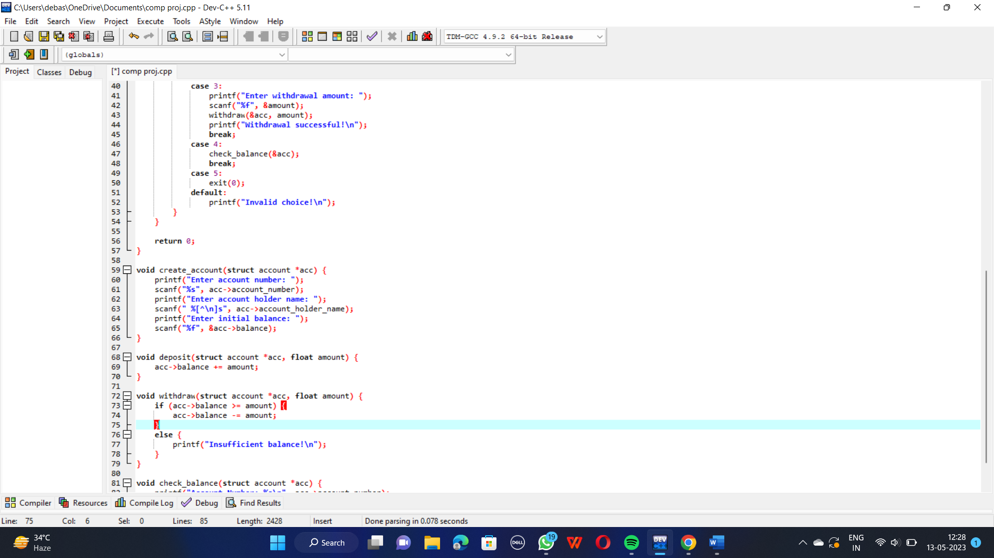

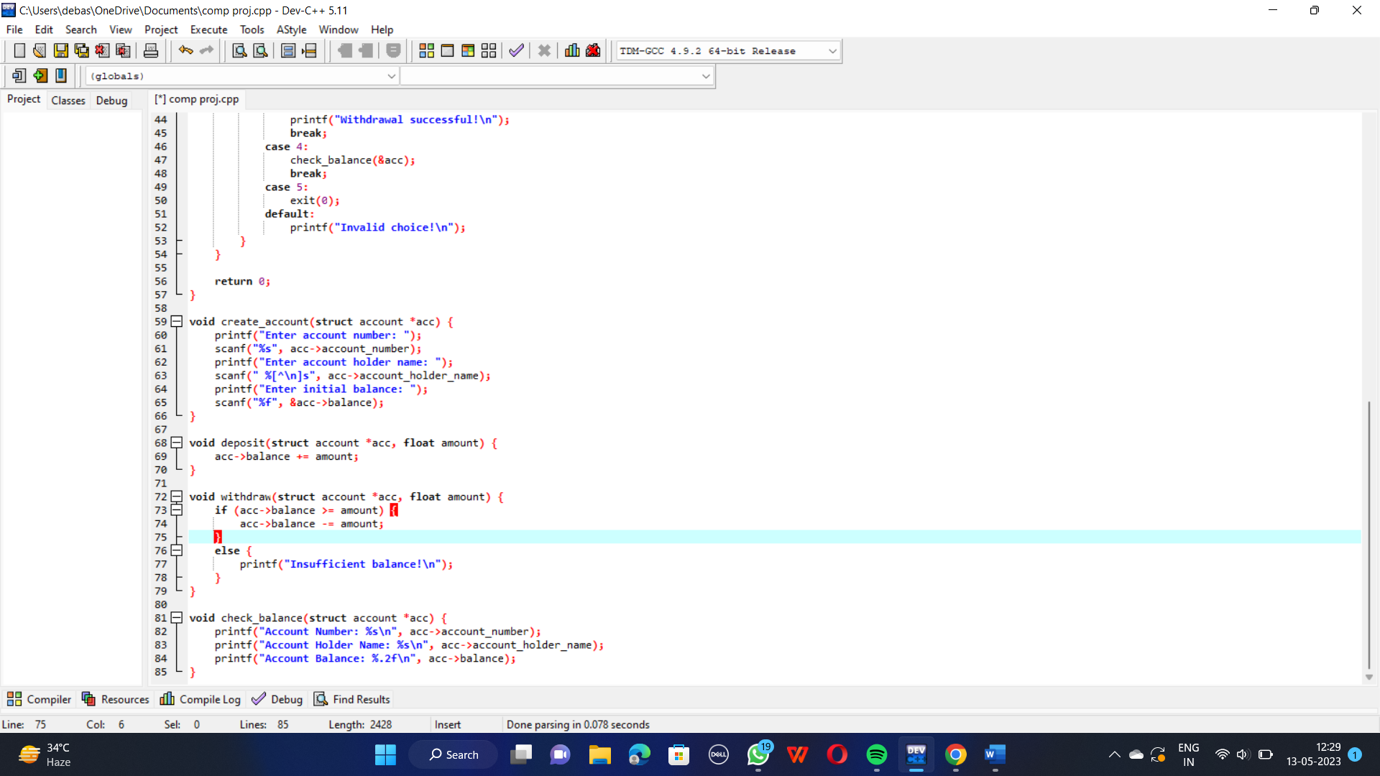

# 5.Outputs

